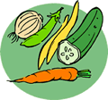
Vegetables
plant that can be partially or wholly eaten
Vegetables contain more and less______ than fruits.
Botanical Classifications

Leaves -
Stems and shoots –
Roots –
Tubers -
Bulbs -
Seeds -
Fruits-
Flowers –
Color and nutrient value

Red:
Green:
White:
Yellow:
Vegetables provide the following Vitamins and Minerals:

Vegetables contain NO _____.
They are low in , and (They are “Nutrient Dense”)
Choose , , or vegetables
Eat , and dark vegetables.
Three things that destroy nutrients in vegetables:
1.
2.
3.
Wash vegetables before eating to remove and dirt that might remain on the skin.

The two BEST methods for cooking vegetables are:

1.
2.

You can also:

1.
2.
3.
4.

Four ways to preserve nutrients when cooking vegetables are:
- Cook in rather than pieces.
- Use small amounts of .
- Cook until .
- Save cooking to use in soups or gravies for added .

Select Vegetables that are:

1.
2.
3.
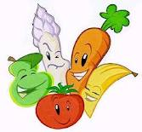
4.
5.
6.
7.

