**Asparagus Carrots Green Beans**

**[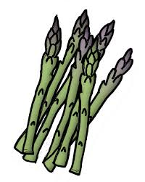](http://www.google.com/url?sa=i&rct=j&q=&esrc=s&source=images&cd=&cad=rja&uact=8&ved=0CAcQjRxqFQoTCKim0dLO9MgCFUI6iAod9f0AIg&url=http://pilladvised.com/2012/05/impress-your-date-with-asparagus/&psig=AFQjCNF4LgcQgPw1lfofYDcVTv9iMTvG9A&ust=1446652483873746)[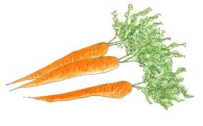](http://www.google.com/imgres?imgurl=http://i.telegraph.co.uk/multimedia/archive/02447/carrot-salad_intro_2447024b.jpg&imgrefurl=http://www.telegraph.co.uk/foodanddrink/9756000/Freshen-up-with-a-carrot-salad.html&h=388&w=620&tbnid=qqqGtjE0vGegTM:&docid=HlETfQ5hJvAkvM&ei=DNk4Vqv2E8b1oASPuaXgAw&tbm=isch&ved=0CCsQMygoMCg4yAFqFQoTCKuske_O9MgCFcY6iAodj1wJPA)[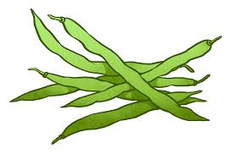](http://www.google.com/imgres?imgurl=http://www.greenbeanshumor.com/wp-content/uploads/2014/02/Green-Beans-REVCLR.png&imgrefurl=http://www.greenbeanshumor.com/&h=1663&w=2528&tbnid=KnG4W8wnx-KY7M:&docid=YPxpMtbU6ug08M&ei=M9k4VvGKG8PJogTlqZqgBw&tbm=isch&ved=0CEoQMygmMCZqFQoTCLHw5IHP9MgCFcOkiAod5ZQGdA)$2.58/cup $.40/cup $.70/cup**

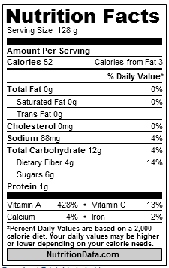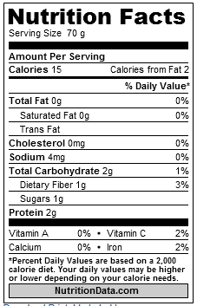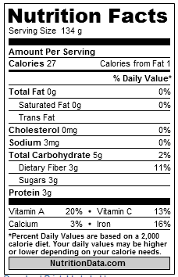



[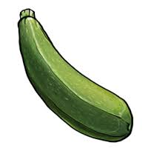](http://www.google.com/imgres?imgurl=http://findicons.com/files/icons/1187/pickin_time/256/zucchini.png&imgrefurl=http://findicons.com/icon/126322/zucchini&h=256&w=256&tbnid=c8f_M5I3ubimeM:&docid=7Ha1WMe3diPpuM&ei=Mto4VtbCN9LIogSW96xw&tbm=isch&ved=0CF4QMyg6MDpqFQoTCNajzfvP9MgCFVKkiAodljsLDg)**Cauliflower Zucchini Mushroom**

**[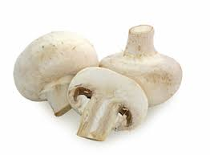](http://www.google.com/imgres?imgurl=http://www.bestinseason.ie/files/2009/06/pic_mushrooms1.jpg&imgrefurl=http://www.bestinseason.ie/a-z/mushrooms/&h=265&w=360&tbnid=8GucPsFG-F1UTM:&docid=sKK2pOs8_RgRIM&ei=zts4VvHtE8rSoATr2Kr4BQ&tbm=isch&ved=0CBEQMygOMA44yAFqFQoTCPGM5L_R9MgCFUopiAoda6wKXw)$.93/cup $.85/cup $.59/cup**

**[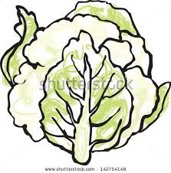](http://www.google.com/imgres?imgurl=http://image.shutterstock.com/display_pic_with_logo/831574/142754146/stock-vector-fresh-cauliflower-head-vector-illustration-142754146.jpg&imgrefurl=http://www.shutterstock.com/pic-142754146/stock-vector-fresh-cauliflower-head-vector-illustration.html&h=458&w=450&tbnid=0mT2yuBiLMzpAM:&docid=JkpR4ab1SVaZCM&ei=ctk4Vu7qC9S1oQTb07SgDA&tbm=isch&ved=0CE0QMyhKMEo4rAJqFQoTCO7r2p_P9MgCFdRaiAod2ykNxA)**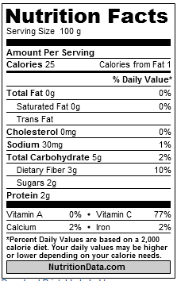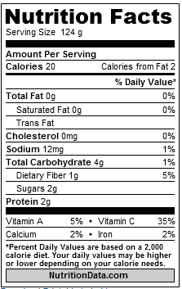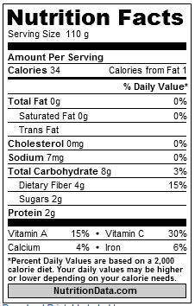

**Stir Fry Vegetable Mix**

**[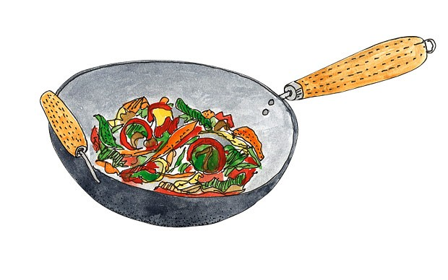](http://www.google.com/url?sa=i&rct=j&q=&esrc=s&source=images&cd=&cad=rja&uact=8&ved=0CAcQjRxqFQoTCP78o4fS9MgCFYgriAodWkwKJg&url=http://www.telegraph.co.uk/foodanddrink/healthyeating/10412539/Wok-around-the-clock-in-search-of-the-perfect-stir-fry.html&bvm=bv.106674449,d.cGU&psig=AFQjCNHm_EzSKRce3BweHlR3n9X6__kp5w&ust=1446653363336090) $1.20/cup**

