MyPlate
List the key consumer message for each food group, list suggestions in the boxes below

Grains:

Protein:

Vegetables:

Fruits:

Dairy:

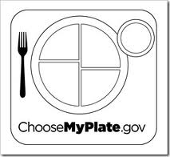
Fill in the number of servings YOU need daily, color each food group the correct color.

Food Group | Amount
Grains
Protein
Vegetables
Fruits
Dairy

