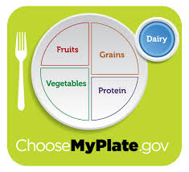
Milk is part of the food group.
Key messages

How many servings of dairy are needed each day?

Examples of serving sizes:

Milk products provide the following nutrients:

Milk is fortified with this means that those vitamins are added to milk.

Pasteurized milk has been treated to remove organisms.

Homogenized milk has had fat particles and evenly distributed so the fat will not from the milk.
Choose dairy products that are low in fat, such as:

Three ways to reduce fat in recipes that use milk and milk products:
1.
2.
3.

Milk products easily and need to be cooked at a low temperature with .

Heating milk in the will .

Always check the date stamped on the carton to make sure it has not .
Buy milk that has the date from today.

Refrigerated milk should stay fresh days after the date stamped on the carton

