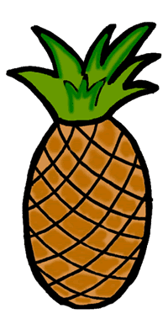
Fresh Fruit and Fruit Dip Lab
Dip: ½ c. Marshmallow cream (1/3 of a 7 oz. jar)
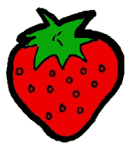
3 oz. cream cheese
Directions: Using a large spoon, mix the marshmallow cream with the softened cream cheese until smooth and creamy. Use as a dip for fruits.
Fruit: 1 banana 1 green apple
1/8 pineapple 8-10 strawberries
1 orange
Fruit preparation: Wash the fruit. Peel and slice the fruit and display it nicely on a plate. Serve with fruit dip.

Fresh Fruit and Fruit Dip Lab
Dip: ½ c. Marshmallow cream (1/3 of a 7 oz. jar)
3 oz. cream cheese
Directions: Using a large spoon, mix the marshmallow cream with the softened cream cheese until smooth and creamy. Use as a dip for fruits.
Fruit: 1 banana 1 green apple
1/8 pineapple 8-10 strawberries
1 orange
Fruit preparation: Wash the fruit. Peel and slice the fruit and display it nicely on a plate. Serve with fruit dip.

