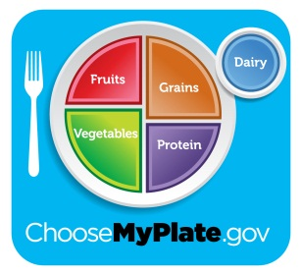 Name: Class Period:
ChooseMyPlate and Caloric Needs
3 Things our Caloric Needs are based on:
- _______________________
- _______________________
- _______________________
Definitions of Physical Activity Level:
____________: lifestyle that includes only the ________ physical activity
associated with typical day-to-day life.
____________: lifestyle that includes physical activity equivalent to walking about 1.5-3 miles per had at 3-4
mph, in addition to the physical activity associated with typical day-to-day life.
____________: lifestyle that includes physical activity equivalent to walking more than 3 miles per day at 3-4
mph.
What are Empty Calories?
Foods that are________ in calories, but ________ in nutrients.
Things to Remember when Choosing Foods:

What foods should we reduce? What should we increase?

What are the Six Nutrients? (Circle the ones that provide calories/energy)
- 2. 3. 4. 5. 6.
How many calories in:
What happens to calories in your body when you do not burn them off as energy? ___________________________________________________
- _____________=_______
- _____________=_______
- _____________=_______

